Transcription

Assessment Statements
- State the names of the four bases in DNA and mRNA
- Explain the process of transcription, including initiation, elongation and termination
- Outline the difference between introns and exons and their role in splicing
- Outline the advantages of alternative splicing
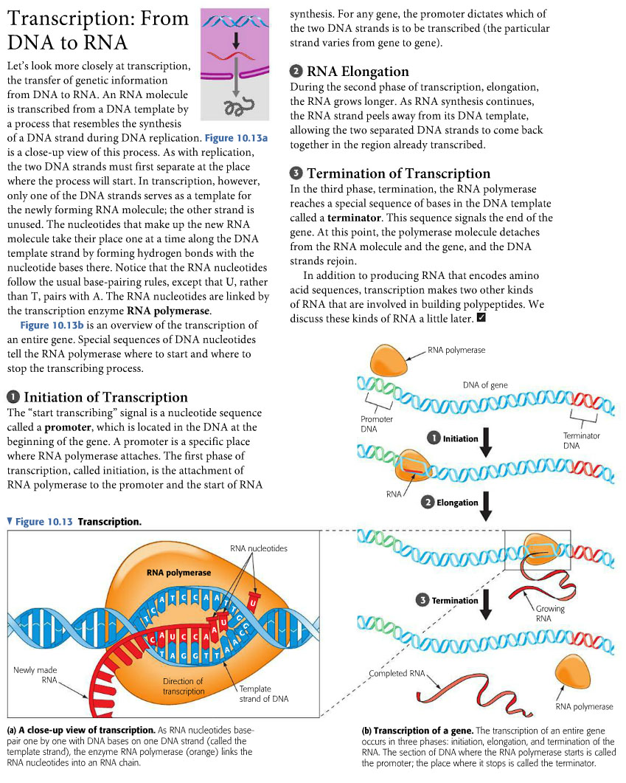

Posttranscriptional processes
After transcription is finished, further processes take place to modify the mRNA.
Probably surprisingly, 99% of our DNA does not code for protein information! Only the 1% of the DNA called exons contain information for proteins. The non-coding introns are removed by a process called spicing. The mRNA, now only built with exons, will then go to the ribosome and the cut-out introns will be recycled.

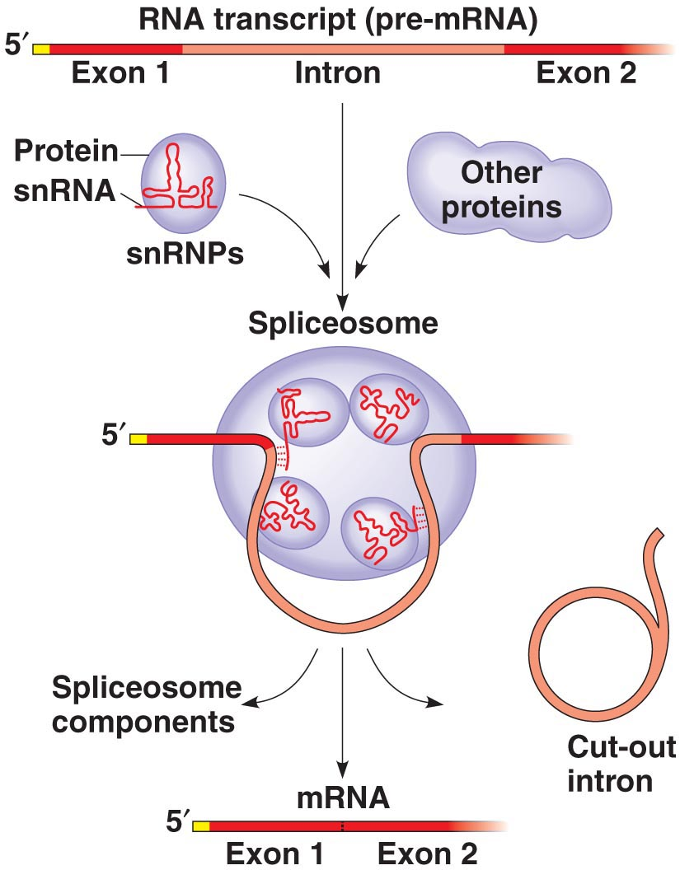

Alternative splicing

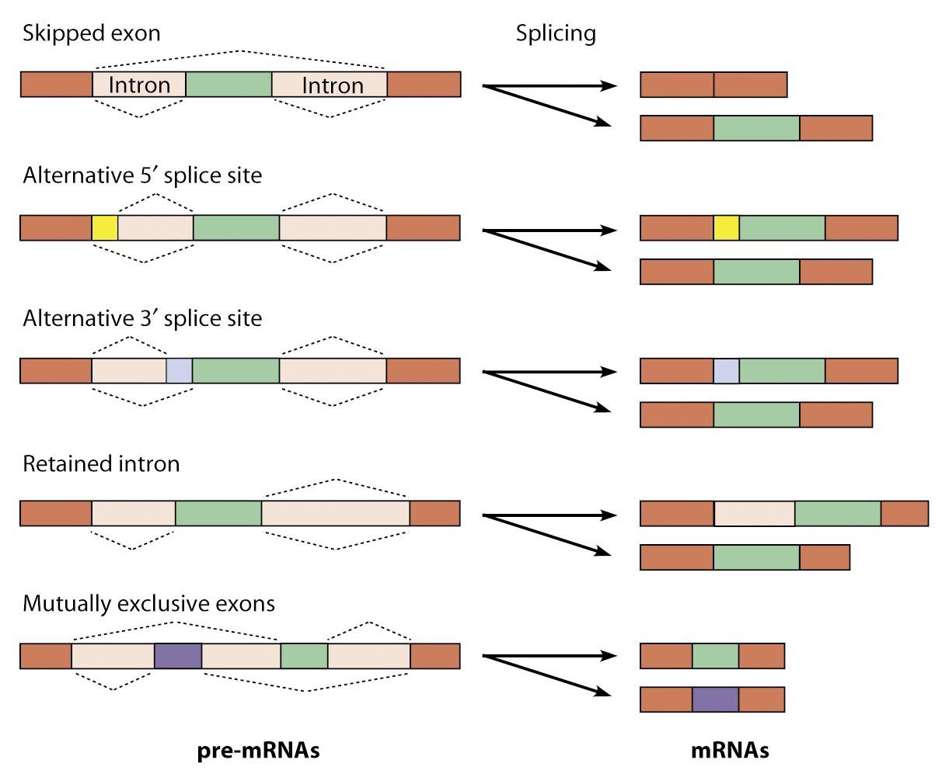

DNA extraction
- Add 5 ml dishwashing detergent in a glass beaker
- Take 50 ml Gatorade in your mouth. Do only use tools allowed for food!
- Rib with your tongue at the inside of your cheek for around 30 s
- Spit the Gatorade into the dishwashing detergent
- Stir gently for 3 minutes; try to avoid foam
- Fill a test tube 1/3 of its size with your solution
- Hold your test tube diagonally and add slowly the double volume chilled ethanol
- Two phases are emerging. DNA precipitates in the contact layer
If you want, you can go on with the experiment
- Use a glass hook or forceps to catch your DNA
- Color your DNA with methylene blue
- Transfer your DNA into an Eppendorf tube and take it home

Why do we have to use dishwashing detergent?

Are you sure you have isolated pure human DNA?

Used Tools and References
- Reece, J. B. et al. (2018). Campbell Biology. (11th edition). Pearson Education.
- Simon, E. J., Reece, J. B., Dickey, J. L. (2013). Essential Biology with Physiology. (4th edition). Pearson Education.

CC BY 4.0 DEED for contents created by Daniel Margadant
For other sources (e.g., figures) please consider © of corresponding reference

